Emergency Response Mapping Sphere


(Insert your team logo here)

Final Report

ERMS
Brandon Le
Kiet Nguyen
Hai Yen Nguyen
Josh Wu
Antony Quach

Department of Computer Science and Engineering
Texas A&M University

Date 4/30
Table of Contents (Be sure to regenerate before submitting).

1 Executive summary (1-2 pages; 5 points) 3
2 Project background (2-4 pages; 5 points) 3
2.1 Needs statement 3
2.2 Goal and objectives 3
2.3 Design constraints and feasibility 3
2.4 Literature and technical survey 3
2.5 Evaluation of alternative solutions 3
3 Final design (5-10 pages; 5 points) 4
3.1 System description 4
3.2 Complete module-wise specifications 4
3.3 Approach for design validation 4
4 Implementation notes (10-20 pages; 30 points) 4
5 Experimental results (5-10 pages; 20 points) 4
6 User’s Manuals (5-10 pages; 20 points) 4
7 Course debriefing (2-4 pages; 10 points) 4
8 Budgets (2-4 pages; 5 points) 5
9 Appendices 5

Executive summary (1-2 pages; 5 points)
As you did with the proposal, the final report should start with an executive summary. In this section, you provide a brief overview of (1) the need, goal and objectives of the project, (2) the final design and implementation, (3) the results that were obtained, and (4) your experiences with team/project management. The intended audience of the executive summary is the program director at the institution/company that funded your project. Since the executive summary is a summary of the final report, it should be written last.

Project background (2-4 pages; 5 points)
Describe the general scope of your project, and the specific problem that your project tackles. Go from general (e.g., search and rescue robotics) to specific (e.g., GPS navigation). This section (and all its subsections) can be expanded from those in the proposal.

Needs statement
Define the specific need that your project addressed. Articulate the need as an expression of dissatisfaction with the current situation. If the needs statement was revised during the semester (e.g., because the initial needs statement may have been too restrictive), please document the changes and provide a justification.
First responders routinely have to enter dangerous structures as part of their jobs. Hazards such as structural integrity, fire, or live threats slows them down during time sensitive missions and risks their lives. From 2018 to 2020, 87% of firefighter injuries occurred during structure fires, highlighting the significant dangers associated with indoor emergency response. Additionally, active shooter incidents last an average of only 12 minutes, leaving little time for responders to assess and secure a scene. Existing solutions are upwards of thousands of dollars and tend to require a skilled operator. These statistics demonstrate the urgent need for a device that first responders can deploy quickly to enhance safety and situational awareness in hazardous environments.
The previously designed Throwable Environment Scanner addresses this need but is lacking in some areas. Currently, its 3D mapping capabilities are not clear enough to allow users to be confident that all threats have been identified, demonstrating a need for improvements in threat identification. Furthermore, users may find it difficult to use the map, showing that a more intuitive user interface is needed.

Goal and objectives
As discussed in the proposal template, the goal is a brief, general, and ideal response to the needs statement. The need describes the current, unsatisfactory situation; the goal describes the future condition to which we aspire. The goal statement is so ideal that it would be difficult to decide when it was achieved. It rather establishes a general direction for the design mission. In contrast, the objectives are quantifiable expectations of performance. The objectives should also include a description of the conditions under which the design must perform. Again, if goal and objectives were revised during the semester, please document the changes and provide a justification for these.

The goal of this project is to enhance the Throwable Environment Scanner so that it can deliver high-quality 3D mapping directly to a first responder’s device while improving existing system efficiency.
The main objective of the system is to utilize onboard cameras to stream live video and reconstruct a 3D representation of the surrounding environment, improving situational awareness and enabling more effective threat detection. At the same time, the device must maintain its portability and durability to remain practical for field deployment. It will be limited to a maximum weight of 3 pounds and a maximum diameter of 7 inches, while also being capable of withstanding drops and collisions in hazardous conditions. The device must support 30 minutes of continuous operation at a minimum to ensure reliability during active incidents and be able to start up within 30 seconds to reduce delays. Additionally, the project must remain within cost constraints, with a maximum budget of $250 allocated for design iterations. The system must also provide threat identification in the environment to reduce mental load on users.

Design constraints and feasibility
Describe the constraints (e.g., technical, physical, economical, temporal) that you had to work with. Again, if these were revised during the semester, please document the changes and provide a justification.

One of the primary challenges of this project is ensuring that the first responder’s get an accurate representation of the environment with low latency. The 3D model generation and threat identification must take less time than traditional methods of ensuring safety in dangerous structures. Processing and reconstructing high-resolution spatial data requires significant computational resources, which may introduce latency and limit real-time usability. Additionally, the device must be engineered to withstand strong and repeated impacts, as it is designed to be thrown into hazardous environments. This requires a durable outer structure that protects internal components without exceeding weight and size constraints. Finally, the hardware must support complex transmission logic capable of delivering high-resolution images and mapping data quickly and reliably. Efficient data compression, wireless communication stability, and low-latency streaming will help maintain performance under emergency response conditions. Given that the durability and portability objectives of the system have already been tested, all objectives can be completed fully if threat detection and environment reconstruction algorithms are sufficiently fast and camera data quality is sufficiently accurate.

Literature and technical survey
Describe prior research and development efforts that were specifically related to your project. As stated in the proposal template, this is not meant to be a comprehensive survey of an engineering discipline, but a concise overview of the most significant results that are tightly related to your project. As a guideline, this section should include a review of not less than five commercial products or research projects. This review should conclude with a statement that explains the extent to which your final design is related to these other products/projects (e.g., is it better? or faster? or cheaper? does it target a new niche market?). Expand this section if additional references were found to be relevant during the semester.

While the Throwable Environment Scanner is not the first product to solve the problem of scouting hazardous indoor environments, it does improve on existing solutions by being cheaper and requiring little training to produce a 3D map. Other products might have one of these features, but none of them combine them all. By being cheap and requiring little training, it can be easily integrated into most teams entering dangerous rooms. The 3D model visualization can allow operators to view any aspect of the environment in just a few seconds after the ball has rolled, improving decision making.

Solution | Description | Pros | Cons
The Brinc Ball | Throwable communication device that functions as a telephone | - Capable of communicating with people inside dangerous area | - Does not record video, scan environments, or generate maps
Recon Robotics Throwbot | Compact wheeled surveillance robot for live video and audio | - Extremely durable (30-ft drops, 120-ft throws)  - Up to 60 minutes of battery life | - Requires training to operate and has only one camera angle  - Obstructed terrain can limit mobility
Flyability Elios 3 (Surveying Payload) | Collision-tolerant indoor drone  designed for inspection,  mapping, and 3D environment  reconstruction | - Can actively navigate complex or obstructed spaces | - Not throwable, requires skilled operation, and is high-cost industrial hardware
Bouncing Image Explorer 360 | Throwable 360° tactical ball camera with live phone streaming (WiFi & Cellular) | - Compact, durable, and capable of window impact deployment | - No depth reconstruction (manual viewing only); high cost ($4k–$7k)
Squishy Robotics Stationary Robot | Throwable or aerial-deployable multi-sensor response device | - Highly impact-tolerant; designed for hazardous and disaster environments | - Stationary operation; complex and high-cost system

Evaluation of alternative solutions
Discuss the alternative designs that were considered throughout the project. Analyze the pros and cons of each of these designs, and justify your decision to opt for a particular solution. You may have found additional alternatives aside from the ones in the proposal, so make sure you include all.

- Drones
  - Pros
    - Provide overhead views of environments, including inaccessible or elevated areas.
    - Already commercially available and supported by existing technology.
  - Cons
    - Hard to operate in enclosed areas
    - Requires significant skill from a trained operator
- Grounded Robot
  - Pros
    - Can have mobility in enclosed areas
    - A lot of them carry very sophisticated mapping and recording systems
    - Already being used by some first responders and military units
  - Cons
    - Mobility issues if the ground is obstructed/uneven
    - Usually large and hard to carry. Not very portable
- Throwable Communication Ball
  - Pros
    - Cheap
    - Small
    - Durable
    - Remote communication is highly useful for many areas, not limited to search and rescue, crisis intervention, disaster response, and negotiation/de-escalation
  - Cons
    - Cannot visualize an environment
    - Requires a conscious and willing corespondent; does not work for search and rescue of unconscious people

- Body Cameras
  - Pros
    - Cheap
    - Lightweight
    - Already exists in the market
  - Cons
    - Require a human in the environment, which could be hazardous
    - Remote operators cannot can only view the direction the wearer observes
- 360° Cameras
  - Pros
    - Views the entire environment at once
    - Lightweight and portable
    - Already exists in the market
  - Cons
    - Requires a mount or transportation device to be placed somewhere

Final design (5-10 pages; 5 points)

System description
Please provide a description of the overall system. This description should include a high-level block diagram and a functional description of the different parts and interfaces in your final system. If any of these were revised after the CDR, please document the changes and provide a justification.

Complete module-wise specifications
Provide a detailed design of each subsystem (both hardware and software), including
- Circuit and logic diagrams
- Interfaces and pin-outs
- Timing diagrams and waveforms
- Software processes with their inputs and outputs
- Complete parts list
If any of these were revised after the CDR, please document the changes and provide a justification.

Approach for design validation
How did you test your system to ensure that it did what it was designed to do? If these validation procedures were revised during the semester, please document the changes and provide a justification.
- Camera Quality: The images taken by the camera should be checked to ensure that they clearly picture the environment and objects in the images are easy to identify. The photos captured by the camera will be compared to the environment to ensure accuracy.
- Wireless transmission: Because the ball is intended to be used remotely, the ball must be capable of transmitting wirelessly from a distance through walls and objects. To test this, we plan to operate the ball through 10m of obstacles and evaluate for latency and data loss.
- User interface: Because our tool is meant to have little operator training required, the user interface must be intuitive and easy to use. To test this, we will use third parties as operators. While the test operators use the system, we will observe them and ask about their experience.
- Mapping algorithms: If the 3D environments are not accurate to the real environment, operators may make decisions based on incorrect information. We will compare the generated environments against measurements of the real one to ensure accuracy.
- Live object identification: Hidden live objects may not be easy for operators to identify. To ensure the system can identify live objects, we will operate it in an environment with humans and or animals, in varying degrees of hiddenness, and compare the generated flagged objects to the real ones to ensure that the system does accurately flag live or moving objects.
- Lifespan test: The device must operate for long enough that it can be used to explore multiple environments and to monitor changes in environments. The ball will be fully charged and operated until it runs out of battery to determine its lifespan.

Implementation notes (10-20 pages; 30 points)
This is the single most important section in the final report. It should contain “engineer's notes” that would allow a reasonably skilled engineer to understand, reproduce and modify your group’s products.
Remember that figures should include labels and captions and be referenced directly in text. An example of a figure with a label and caption can be seen in Figure 1. Additionally, tables should also be labeled and captioned and a direct in text reference. Table 1 shows an example of a labeled and captioned table. Labeling and caption may be painful to do in Google Docs as was done here, but it should be easier in MS Word, and significantly easier in LaTeX.

Table 1: A parts list of materials that are needed to build the design. Note that the label and caption are above the table. The specific format of the table is flexible, I have given a basic example to illustrate labeling and captioning.
 | Amount | Amount per Unit | Cost per Unit | Total Amount ($)
2x4” Lumber | 23 LFT | 1 | 23 | 23
Deck Screws | 1 | 50 | 7 | 7
Raspberry Pi | 1 | 35 | 1 | 35
… | … | … | … | …
Total Cost | $65

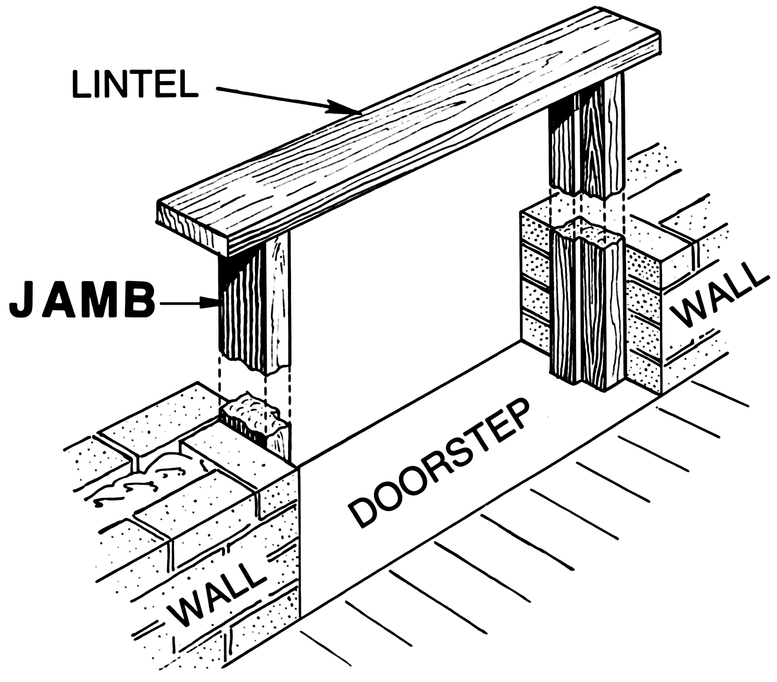
Figure 1: Rough blueprint for how the door frame will be attached to the wall. The motion sensors will be placed on either of the door jambs, roughly where the arrow points out where the jambs are. The lintel will be where the camera is mounted. Note that the label and caption are below the figure.

Experimental results (5-10 pages; 20 points)
This section is also very important, as it shows whether or not your project worked. You should provide:
- A description of the tests you performed to validate the system,
- Numerical results of these tests,
- A thorough analysis and discussion of these results, and
- A collection of pictures of your final system

User’s Manuals (5-10 pages; 20 points)
This document should contain detailed (1) hardware installation, (2) software installation, and (3) operation instructions for the users of your product(s). It should be aimed at the “average user” of your system (please identify the characteristics of such user) and should not require that the reader be an engineering professional.

Course debriefing (2-4 pages; 10 points)
This document should contain the group’s collective answers to the following issues.
Provide a thorough discussion of your team management style. If you were to do the project again, what would you do the same, what would you do differently?
Are there any particular safety and/or ethical concerns with your product(s)? What steps did your group take to ensure these concerns were addressed? Are there any additional steps you would have taken if you were to do the project again?
Did you test your product(s)? Do they work as proposed? Can you think of any relevant situations in which you haven’t tested your product(s)? If you were to do this project again, what additional verification and testing procedures might you add?

Budgets (2-4 pages; 5 points)
Summarize the costs of the prototype, including parts list with sources, and any support tools required (with costs.) Provide (1) detailed cost breakdowns, (2) a short narrative summarizing the costs, and (3) a comparison of these costs with the proposed budget and with your estimate of the cost in mass production.

Appendices
Here you can include any additional information not already in the implementation notes (e.g., detailed circuit schematics, class hierarchy) that would help replicate or maintain your implementation.

References
Here you acknowledge all the documents that you used as references throughout the text. Please use the IEEE reference format.
https://ieeeauthorcenter.ieee.org/wp-content/uploads/IEEE-Reference-Guide.pdf

